Gizmoball: Weekly Progress Document (Week 7)

CS308 Group MW1

**New issues:**

* Switching from build mode to play mode, do we need to be able to load an unsaved build from build mode into playmode (Greig)
* Absorber needs complete reimplementation before merge into main project
  + Currently trying to avoid internal collision with top line segment when ball shot
* Ball sinks down in every line segment once it stops bouncing (when gravity is applied)
* Having problems moving from single Ball object to arraylist of balls in Model class (mainly for collisions)
* Use of Randoop for testing part of Model?
* How to draw ball on top of Absorber (ball not hidden)
* Not able to figure out how to increase frame rate

**Ongoing issues:**

* Currently implementing collisions using redrawn flippers without animation. Going quite well. (TM)
* Still adjusting gravity/friction calculations
* Decide on how to handle switch between Build Mode and Play Mode (what classes)
* Merging of git branches and resolving conflicts
* Merging of prototypes to one project

**Resolved issues:**

* Both Flippers can now be drawn and controlled in terms of left/right flippers using “Q” and “E” keys. No animation, just redraw.
* Absorbers now absorbing from all sides and drawing on the board following width and height in View, x1, y1 and x2, y2 in Model
* Tidying up of local projects (deleting unnecessary ones)

**Goals for upcoming week:**

* Finish with the refactoring and merging of the prototypes.
  + Collisions working on flippers in activated and deactivated states
  + Perfect gravity/friction calculations
* Have absorber working following the official specs and added in main project
* Loaded board can be used to play and see collisions (hopefully with absorbers too)
* Separation and switching between Build Mode and Play Mode complete

**Git repository history:**

* Commits on the several branches:
  + David branch:

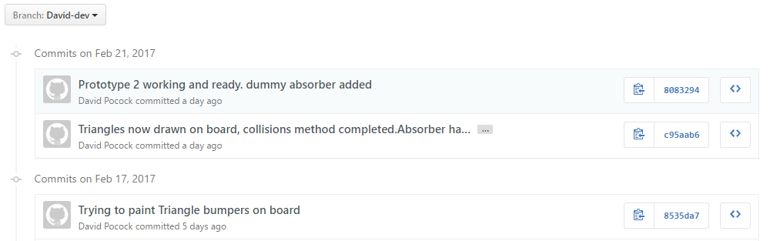

* Greig branch:

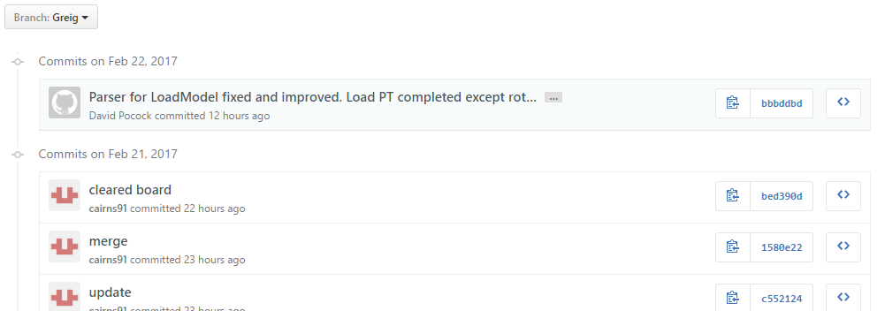

* Chris branch:

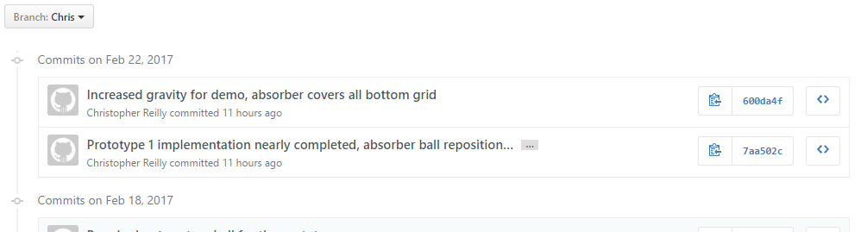

* Thomas branch:

